Yoga Lesson Plan

Alyssa Van Stone, Piper Dedels and Jessica McDougall

Professor: Dan Geneau

EPHE 311 A02

February 4, 2021

Lesson #: 1 of 4  Topic: Yoga  Grade(s): 6-7  Level: Easy/Moderate  Materials/Resources:  -Yoga mat or gymnastics mat  -Proper yoga attire  -Proper footwear (preferably bare feet) | Learning objectives: TSWBAT…  -Carefully listen to and follow the teacher’s instructions while maintaining proper position and physical movements.  -warm up direct muscles that correspond to the later culminating activity.  -Maintain a relatively calm and relaxed mindset while following along with instructed poses, ensuring to keep the body balanced and composed.  Psychomotor Skills:  -Physical movements, stretches, balance, posture, core, flexibility.  Cognitive Skills:  -Pay attention to instructions given, listen to incoming information and move the body according to the poses instructed.  -Recognize patterns and feelings from certain movements of the body.  -Adjust body accordingly and notice the poses relation to the music.  Affective Skills:  -Behaviour and attitude management (maintain positive attitude towards instruction, calm and collected mindset, breathing in and out regularly, relaxing muscles and body, clearing mind).
Parts of the lesson  Activities:  - Warm up  - Yoga flow/Body  - Stretching - static  - Breathing exercises  - Culminating Activity |  | Time  15-20 Mins | Teaching Points  -To focus primarily on warming up the muscles used in later yoga lessons.  -Introduce creating a positive and relaxing atmosphere and mindset prior to engaging in actual yoga poses.  -Calm the body and release tension to fully experience and embrace the impacts of yoga.
Lesson Descriptions  Warm-up (Series of Yoga Warm-ups):  - Name: Slow and Steady March Exercise  -Stand up straight with hands at sides to begin and feet touching each other.  -Proceed to lift legs into a high knee position while staying on the same part.  -While lifting one leg up, move your arm into a march-like position while lifting the opposite leg at the same time.  -March on the spot and keep arms at a 90 degree angle.  -Continue these physical movements while remaining in the same spot on the yoga mat.  - Name: Cross-body Toe Touch Exercise  - Start with both hands in the air over your head with legs just over shoulder width apart.  - Using one arm, reach down to touch the opposite foot.  - When coming up both hands are in the air, switching back and forth between legs.  - -Continue to move at a sufficient pace best for you by touching arms to the opposite leg.  - Name: Arm Circles Exercise  - Move arms in a circular motion starting with large circles. Start slow and increase speed. Move into smaller circles throughout.  - Switch directions.  - Name: InchWorm Exercise  - Start in standing position feet shoulder-width apart.  - Reach hands down to the floor in front of feet and use hands to crawl to the opposite end of your yoga mat.  - Name: Lunge Tap Exercise  - Feet a little over shoulder width apart, use one arm to reach for the opposite foot in a side lunge position.  - Name: Squat Cross Arms Exercise  -Begin in standing position and set feet just over shoulder width apart.  -Position legs into a squat like position, bending the knees while maintaining a straight back.  -Move arms up and down along the sides of your body while also moving up and down with legs.  - Name: Cross Jacks Exercise  -Similar to a jumping jack, students will continue to perform jumping jack leg movements by moving their legs side to side while jumping to complete this movement.  -Maintain a straight leg position while moving legs to the side each jump.  -Instead of moving hands up and over your head like jumping jacks, move arms across the body while crossing them over each other each time.  -Legs will extend to the side while jumping while simultaneously moving arms across the body back and forth.  **Did static exercises due to teaching on zoom circumstances**  *Alternative Option for a Warm-up if in Person*  Name: Yoga Tag  -Students are put into two teams (equal numbers on teams) and spread out around the gym in preparation for a tag game.  -Two people from each team are designated as being “it”.  -Once students become tagged, they have to hold a tree pose until someone from their team comes by to save them.  Yoga Flow Sequence (Body):  - Mountain Pose:  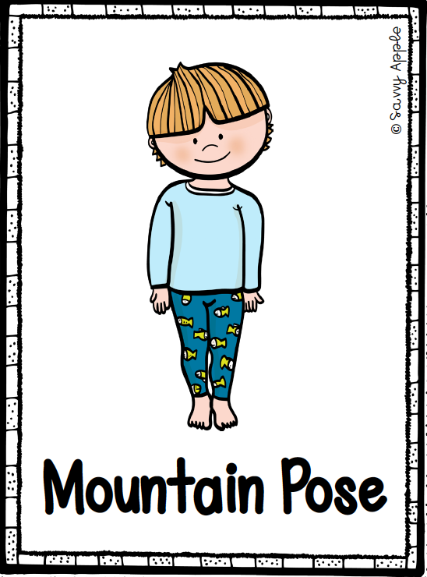  -Standing up straight with feet together and hands by your sides  - Standing Pose:  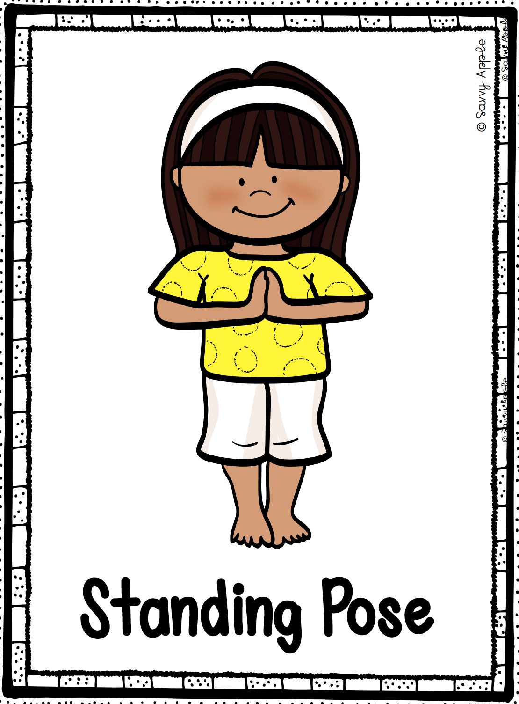  - Bring the hands together at heart centre  - Warrior 1 Pose:  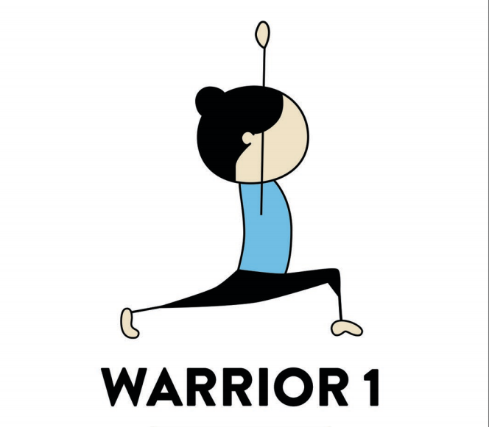  -Align legs into lunge position with one foot forward and one foot back .  -Back foot should be resting on their toes.  -Raise hands up above head along the side of the body.  -After one rotation proceed to switch legs  - Raised Hands Pose:  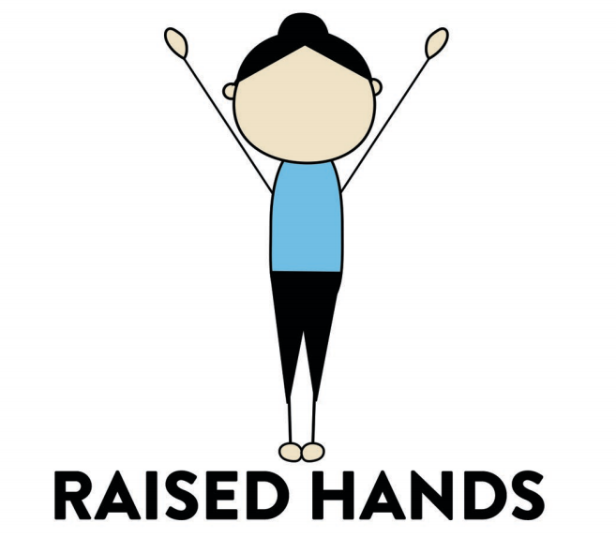  -Feet together and raise hands above head from the sides  -Keep feet together  - Forward Bend Pose:  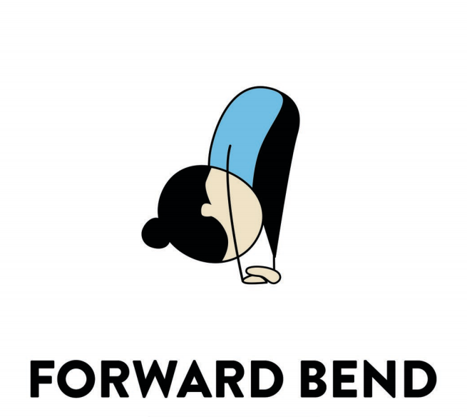  -Stand up straight and proceed to bend over and touch your toes (if able) while maintaining straight arms  - Downward Dog Pose:  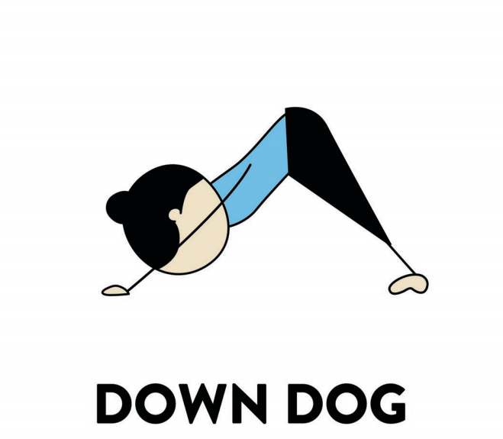  -From standing position, crawl forward with hands until bent over with straight a back and straight legs  - Plank Pose:  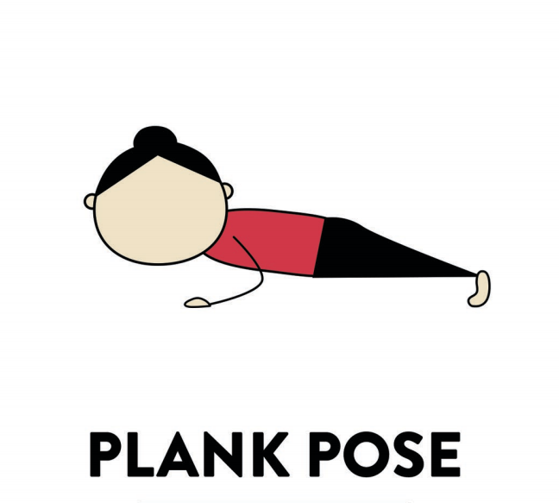  -Transiting from downward dog, crawl forward until can place elbows on the ground  -Keep a flat back and use toes as support into a plank position  - Upward Dog Pose:  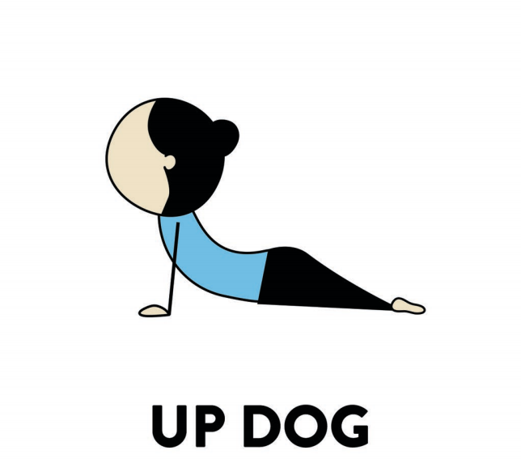  -From Crocodile Pose, bring arms up from sides and place flat on ground just over shoulder width apart  - Arch your back with legs remaining flat and close together  -Face head up to the ceiling  - Chair Pose:  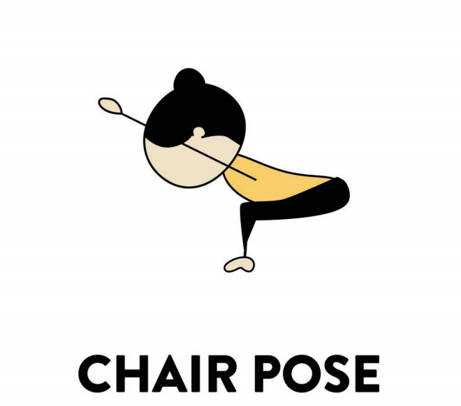  -From Upward Dog Pose, crawl arms back while standing up until knees are bent  -Once knees are bent, bend back while keeping a flat back  -Move arms up beside head and position head between elbows  - Tree Pose:  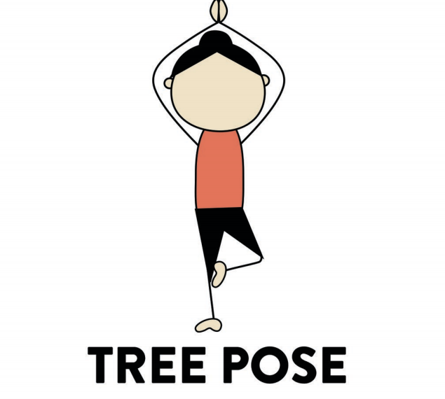  -From Chair Pose, stand body up straight  -Lift arms up and place palms together over head  -Raise one leg at a time and place feet above knee and onto thigh or shin  -Switch to alternate leg after 10 seconds  - Cow Pose:  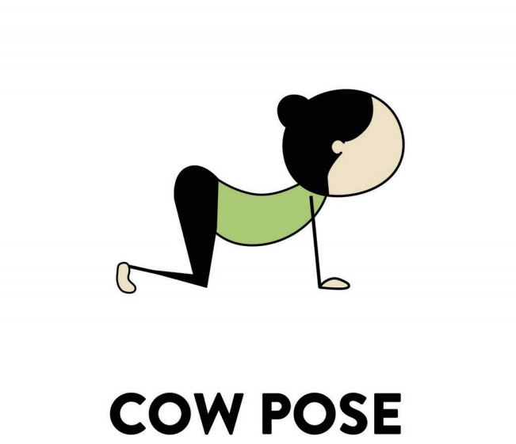  -Following the Lunges, drop each knee (one at a time) to the ground  -Crawl with hands to the front of mat with palms on the ground  - Corpse Pose:  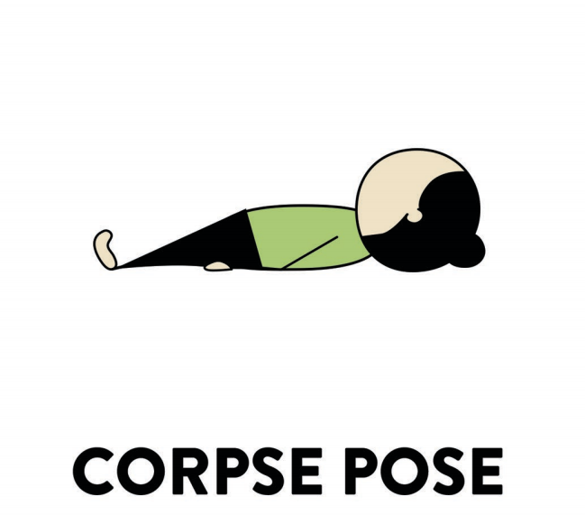  -From sitting crossed legged, bring legs forward out of the crossed position to the front of your body.  -Lean body backwards slowly until laying flat on your back and eyes towards the ceiling  -Arms lay by sides  Safety/Precautions:  -It is important to ensure that you are transitioning between yoga poses during the yoga flow in a way that is most comfortable for your body.  -Transition between poses slowly and collectively.  -When asked to touch toes or bend in a certain direction, ensure that you are only bending to the point that is most comfortable for your body.  Post-Yoga Breathing/Stretching:  -Lay on back in Corpse Pose. Lift arms up above head (while keeping hands on the ground). Breathe in and out ten times.  -Bring one leg up to chest and hold with arms to stretch back of hamstring. Take five breaths then switch legs. Place both legs back on the ground once complete.  -Bring one leg up to chest and cross the other leg over it in order to stretch glutes and hips (support leg lifted to chest with hands). Switch legs after holding for ten seconds.  -Rise into a seated position. Stretch one leg out to the side to stretch the calf muscle, place hand on thigh, knee or shin if unable to reach toes and breathe. Switch legs.  -Sit up and tough the bottoms of the feet together. Bring feet as close to the body as feels comfortable. Feel the stretch in groins and hips.  -Remain seated and place legs straight forward and flat. Twist upper body over to one side to stretch the back. Breathe deeply and then switch sides.  Culminating Activity:  Name: Strike-a-Yo Pose!  -For the culminating activity, the aim is to get students to execute the above yoga flow poses to the best of their ability in order to demonstrate their learnings in class and showcase their yoga competence.  -For this activity, students will be put into groups of four (number depends on amount of students in the class) and will be required to design their own yoga flow sequence. This sequence will consist of three of the above yoga flow poses previously taught. Students will also be required to create an additional pose of their choosing to include in their yoga flow sequence.  -Students will need to work as a team. They will engage with new learnings by choosing three of the above yoga flow poses and then also use their imagination and creativity (collaboratively) to create a pose of their own. Students will then perform their sequence in front of their classmates.  -Students must work collaboratively to select these poses and design their own pose.  -Each group of students will have 2-3 minutes each to perform their desired yoga flow sequence in front of the class.  -Students will demonstrate their knowledge of the yoga poses while also verbally instructing the rest of the class while performing.  -While each group is performing and demonstrating their yoga flow sequence, the rest of the class will be flowing along on their own independent yoga mat.  -Since each group will also be creating a yoga pose of their own, students will be able to learn a few yoga poses in addition to the poses previously taught by the instructor in the yoga flow sequence.  -Students will learn a plethora of yoga poses to use in the future. They will also have a method to calm and relax their bodies when needed. |  | 7 minutes  7 minutes  10-12 Minutes  5 Minutes  10-12 Minutes | Intention of Warm-up:  -The purpose of these warm-ups for yoga are to stretch out the muscles in an active way to be able to move on safely to the next part of our lesson.  -Each exercise targets a different stretch that is vital to stretch out prior to engaging in the ensuing yoga activities.  -Stretches out hips to ensure that they are loose for proper physical movement.  -Stretches out groins and hamstrings and other various muscles in legs for proper movement and stability for balance.  -Alleviates muscle tension and tightness in neck and in shoulders.  -Each exercise enables flexibility for muscles.  Teaching Cues for Warm-up Exercises:  -Remind students to take these exercises slow.  -Slow and steady movements to get the body warmed up  -Start with slow circular motions, increasing speed when it feels comfortable.  Teaching Cues for Yoga Tag (Alternative Warm-up Game)  -Instruct students to tag appropriately and gently.  -Important to be honest when tagged and complete activities truthfully.  Teaching Cues (Yoga Flow):  1)Mountain Pose:  -Teaches correct alignment and strengthen lower body muscles  2) Standing Pose:  -Ensure to keep straight arms and straight legs  -Inhale and Exhale  3) Warrior 1 Pose:  -Hands stay straight when raised above head  -Keep feet in one spot  -Distribute weight evenly throughout both feet  4)Raised Hands Pose:  -Keep legs and back straight  -Keep arms straight while lifting them above head  -While lifting arms above head, proceed to inhale and exhale while bringing them down once complete  5) Forward Bend Pose:  -Flexibility within students will differ therefore some students may place hands on thighs or shins  6) Downward Dog Pose:  -maintain a straight and flat back  -maintain straight arms when crawling down, bending when necessary  -crawl down until it feels comfortable  7) Plank Pose:  -While crawling down to plank position ensure to remind students to breathe  Modifications for Plank Pose:  -If students are struggling with this transition, students can skip plank pose and proceed directly into plank pose  8) Upward Dog Pose:  -Keep arms straight and legs straight while arching back and head to the ceiling  -While crawling up into proper position proceed to breathe in and exhale once face is up to the ceiling  9) Chair Pose:  -Keep arms straight  -Head and back flat while keeping knees bent and weight on your heels  10) Tree Pose:  -Ensure foot is not on knee, rest foot above knee on thigh  -Arms up and over head while maintaining a flat back and upright posture  -While lifting hands over head inhale, when switching to opposite leg exhale  11) Cow Pose:  -Stretch forward distributing weight between knees and hands  -Breathe in and exhale out while arching back  12) Corpse Pose:  -Transition slowly backwards  -Take a few moments to breathe and relax in this position  Teaching Cues and Modifications for Breathing/Stretching:  -Instruct students to constantly be breathing in and out as instructed.  -If students are unable to inhale and exhale as directed they are able to breathe at their own desired pace.  -Instruct students to transition between stretches comfortably for their own bodies.  -Students should be moving slowly and completing stretches until they are able to feel it in their muscles.  -Each stretch should be held for approximately 10-12 seconds to attain a sufficient stretch.  -Very important to stretch after poses to relax muscles and continue to calm the body down after muscle and mental fatigue.  Teaching Cues for Culminating Activity (Strike-a-Yo Pose!):  -Encourage students to work collaboratively and positively in a team environment.  -Allows socialization between students to promote relationship building and cooperative learning.  -Encourage students to use their imagination and engage with the activity creatively.  -Instruct students to work in a positive manner and welcome everyone’s opinion so each student feels heard and valued.  -Once students are in their groups check in with them to ensure they understand the task.  -Use this culminating activity as an opportunity to assess and evaluate student understanding of new concepts and body movements.
Closure
-Highlight the importance of breathing and the positive impacts of yoga on physical and mental health
-Emphasize to maintain positive mindset while ensuring body is calm and mind is at ease

Reflection Questions:
-What does it feel like to be relaxed and calm?
-What does it feel like to have your muscles flexed and stretched out?
-Does yoga help create a positive mindset? Does the breathing help this?
-What was the hardest part? What is the easiest?

UDL Inclusion:
-It is important to keep in mind that each student is unique in their own way and that each student has a diverse method of learning and retaining information. Because of this, it is important to have modifications towards each planned lesson to accommodate the differences of learning styles for each student
-For example, some students may feel anxious towards yoga and sensitive towards the sounds playing from the music yoga during the length of the activity
-In order to mitigate and alleviate these possible stresses, it is important to create a calm and relaxed environment for students to feel comfortable and at ease while participating
-Since some students may be sensitive to sound or even easily distracted in a quiet setting, it can be vital to include calm music during the activity
-Calm and relaxed music can promote a peaceful atmosphere for students to calm their bodies and mitigate any feelings of distress and help with any sensitivity they may experience during this activity

References:

https://drive.google.com/file/d/14rlinfSnDyTmqGpUNs7AAwRySMhPpTDX/view

Yoga Poses (n.d) Retrieved February 6, 2021, from:
https://drive.google.com/file/d/14rlinfSnDyTmqGpUNs7AAwRySMhPpTDX/view

UDL Guidelines (2018, January 16). Retrieved February 4, 2021, from http://udlguidelines.cast.org/representation/perception

