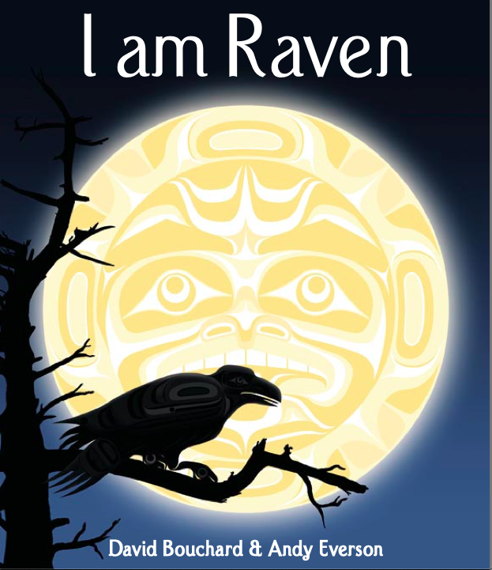TITLE (Haven’t chosen one yet):
Written by David Bouchard, Illustrated by Andy Everson, 2007, Library and Archives Canada Cataloguing in Publication, MTW Publishers

Depiction: The cover of this book has something that could be on a totem pole as the moon, and a raven on a branch which is an influential animal within this book.

Abstract/Summary:
The story is about discovering yourself as a totem and understanding your true identity. Throughout the story one can see how there are many different characteristic traits throughout each animal and that each one brings contrasting strengths. This story has been passed down for many generations and can only be shared when asked “what is my totem?” The main character within the book is a chief. The chief is known to be a wise and kind soul, therefore all the animals always go to him for advice. Throughout the story he is on a mission to carve a totem pole so when he passes into the spirit world everyone can remember him by it. In order to create his totem pole he needs to go through all the proper Indigenous protocols. On his journey to creating his totem pole, he runs into many different animals: the Beaver who is the builder, the Bear who represents protection, the Wolf who symbolizes a teacher, the Owl who shows wisdom, the Eagle who brings smartness, the Frog who represents fertility, the Killer Whales who symbolize family, the Otter that carries friendship, and finally the Thunderbird who represents great power. All these animals that the chief ran into offered their gifts to him with great respect, as they honour him tremendously. Finally continuing his journey he stumbles upon Raven who does not offer the chief a gift. The chief questions Raven as to why not. Raven replies with “Great Chief I am your totem” hence the story title. The next day all the animals and chief came together to celebrate the birth of the new totempole. They danced, they sang, and to surprise they all knew who the chief totem truly was.

Why did we choose this story?
This story connects to finding your own personal story as well as identity. It also is a great reminder that everyone is different and everyone brings their own unique gifts into the classroom. This story shows great visuals that allows students' imaginations to flourish. Lastly, this is an Indigenous book which is a great start on bringing Indigenous Education into the classroom through Drama.

Focused Drama learning outcomes: 3 of them
Two cross-curricula outcomes: Indegenous culture studies; Teaches about importance of Totem poles in the culture and how nature is

Key Questions/Statements:
- Finding true identity in oneself can be a lifelong process.
- Does relating yourself to an animal help one find their identity in life? How?
- Why is it that stories who get passed down from others leave such an impact on our lives?
- Can your identity change over time?

Grade Level:
1.Warm up Activity - Name Game Echo
Time: 5 mins
Grouping: Standing in a circle
Strategy: Get the students bodies/minds moving
Administration: Students names
Focus: Warming up their bodies and brains

Teacher:
We are going to start off our story drama by a quick warm up activity, to get to know each other and different types of animals which we will be exploring today.

Students:
Create the circle

Teacher:
Ask the students to create a circle. One person begins by saying his or her name, and performing an animal action. The group echoes the name and movement. As the next person goes, they say the previous students name and movement, along with their own. This is a memory game. Students are working together to help the leader calling out each turn. This goes on until all students have gotten a chance to do their action.

Teacher:
Emphasize on dramatic effect when saying their name, as it will help students remember better.

2. Starting the creative thinking mindset
Time: 10 mins
Grouping: Everyone together sitting in a circle
Strategy: Brainstorming
Administration: Animals
Focus: To start tapping into students creative mindset

Teacher:
Before starting to read the story out loud to everyone, ask the students to take some time and think about what animal they best connect with and why.

Students:
Once you have given them some time to think about the question… go around the circle and ask each of them what their answer is.
Teacher starts by giving an example of theirs (I connect to the Wolf because to me it represents being a teacher)

Teacher and Students:
When everyone has said their answers. As a group, take a couple of minutes, and allow them to act out their animals all together in tableaus.
Teacher:
Amazing work. Now that you have explored what animal you think describes you best, we are going to read a few pages of the book.
Teacher reads till page 5.

3. Stories from an elder
Time: 10 mins
Grouping: Pairs
Strategy: Storytelling
Administration: sticky notes, a large sheet of paper on the ground
Focus: Remembering

Teacher: Just like the chief, we have elders in our lives too. I am going to tell you a story about a conversation I had with an elder once. I remember when I was a kid, I was misbehaving and not being kind to my mom in the grocery store with my grandmother with us. My grandmother pulled me aside and said “you know, your Mom tries to be the best mom she can.” And this on its own was advice to me. She is always trying to be a good mom.

Just like in this story, we all have heard a story or learnt something from an elder before. This may be a grandparent, or someone who is simply much older than you. Most elders offer advice and tell stories within this. I would like you to think of a time you heard a story or something you may have learned from someone much older than you.

I would like you to get into partners to discuss what this may have been for you. Then I would like you to write down on the sticky notes who this story came from, and what you learnt about in only a few words.

For example, in mine I would put “Grandmother - to appreciate what my Mom does everyday”.

When all the sticky notes have been written on, gather in a circle again

Teacher: Let's gather in a circle now. I would like to hear from a few of you what you learnt from an elder before.

As you are hearing each sticky note, ask the students to put their papers on the big paper for the class to return to if needed.

Teacher: Wow, many of you have learnt so much from elders. In this story, you will see how the elders make a big impact on the writer. This story learns from elders, and from the animals. Let's continue with the story to explore how they do.

4. Adding Traits To Animals
Time: 15 - 20 minutes
Groupings: Groups of 3-4
Strategy: Role
Administration: Masks of various spiritual animal guides from the book
Focus: To explore and connect to different animals

Teacher:
As we have read from the book, different animals have different traits related to them. I would like each of you to get into groups of three and I will give you a mask per group. Each group needs to write an introduction to your animal and the different characteristics you associate with it.

You must give them an example, a good reference would be to the bear as it is associated with teachers.

Put the mask on of the bear and read this short introduction to it:

Teacher in Role:
Hello there, I am Bear. I am a wise and natural born teacher. I am knowing, humble and strong. I have the ability to heal your sick, your children, and your elders. Anyone who bears my ceremonial headdress has the ability to heal, protect, guide and train others in my guardian medicine.
Playing in this role requires you to be confident and of respectable high status.

The teacher must remind the students to act accordingly; they can do this effectively if they make an overview of what traits they believe are relevant to the animal.

You have 10 minutes to brainstorm and pick someone to act in the role of the animal.
[They do]
The teacher can walk around and help groups that are struggling. It is important that they think of these characteristics on their own though. Go around the room and have each group perform.

Now that we have met all the animals, think about whether you connected to any of the animals? Talk to the person beside you. [They do]
Were there some characteristics you disagreed with? Ask if anyone would like to share. [They do]

5. Reading the story
Time: 10 minutes
Groupings: Whole Class
Strategy: Listening
Administration: None
Focus: To understand and connect the story

Teacher will finish the story.

Ask your students what their thoughts are on the story. You can have them share with the whole class. [They do]

6. Chief Meeting the Animals
Time: 15-20
Groupings: Split students into 8 groups - each group an animal from story
Strategy: students in animal role
Administration: using the masks from the previous lesson when talking to chief, chalk/white board and pen, students have pencil and paper
Focus: To provide detail on each animal and why they are special

Teacher:
Alright, let's come back to our circle.

Now that we have met all the animals, let's talk about what makes them unique and different from one another. Just like us, we are all different.

Teacher:
Writes down each animal in the story.

Let’s fill out one together before we go off in our groups.

Teacher:
Writes down chief on the board.

Now, what makes the chief unique? What are some characteristics about him? What is his personality like? What does he look like?
Some of these may be that he is a leader, he is brave, and that he is kind.

Students:
Group brainstorms traits about the chief as the teacher writes on board.

Teacher: I am now going to split everyone up in pairs. I will give each group an animal and you must write down what you know about your animal. What makes it special, and how you have been much like this animal in life.

For me, I have been much like the chief. I am a teacher, which makes me a leader.

Students:
Students are in pairs and write down characteristics and an example of this in their life experiences.

Teacher:
Alright, now, I am the chief. I am here to listen to all the animals plead their case so I can choose who I want on my totem pole.
Let’s hear a little about each one of you.

Students:
Each group describes their animal and talks about an experience in life where they have been much like this animal.

Teacher:

You animals make this a very hard decision. I can tell all of you have something different that is important in life. The Beaver, whom is a strong builder, the bear, whom is a protector and brave, the wolf who is a teacher and generous, the owl, who is wise and kind, the eagle, who is peaceful and friendly, the frog who believes in peace of mind and heart, the killer whale, who are communicators and peaceful, the otter, who loves fun and games, the thunderbird, who is powerful and mighty, and finally, the Raven, who is confident and cunning.

All of these animals have something in common. What do you think this may be? Turn to a partner and discuss.
[Students Discuss]

Teacher:

All of these animals have something to offer in life. They provide a personality trait or characteristic that makes up a person. This story helps us remember that everyone is different and deserves to be treated all the same, with kindness and patience. The chief showed all the animals patience in listening to their pitches and gifts, but in the end, the chief made up his own decision and found himself in the Raven.

We are constantly reminded of who we are through these aspects in the animals, and it is always being reflected on how we treat others and how we take care and find ourselves.

Through friendship, through kindness, and through independence we find who we are.

Reflective Closure:

Assessment:

References:

Presentation:

30 second pitch-
Everyone has an inspiration in their life that they let guide them. This book discusses and helps one to discover their spiritual animal guide in relation to Indegenous Peoples’ beliefs. Find what animal you relate to best!

